Lab 2: Perform SNMP Enumeration

**Lab Scenario**

As a professional ethical hacker or penetration tester, your next step is to carry out SNMP enumeration to extract information about network resources (such as hosts, routers, devices, and shares) and network information (such as ARP tables, routing tables, device-specific information, and traffic statistics).

Using this information, you can further scan the target for underlying vulnerabilities, build a hacking strategy, and launch attacks.

**Lab Objectives**

* Perform SNMP enumeration using snmp-check
* Perform SNMP enumeration using SoftPerfect Network Scanner

**Overview of SNMP Enumeration**

SNMP (Simple Network Management Protocol) is an application layer protocol that runs on UDP (User Datagram Protocol) and maintains and manages routers, hubs, and switches on an IP network. SNMP agents run on networking devices on Windows and UNIX networks.

SNMP enumeration uses SNMP to create a list of the user accounts and devices on a target computer. SNMP employs two types of software components for communication: the SNMP agent and SNMP management station. The SNMP agent is located on the networking device, and the SNMP management station communicates with the agent.

Task 1: Perform SNMP Enumeration using snmp-check

snmp-check is a tool that enumerates SNMP devices, displaying the output in a simple and reader-friendly format. The default community used is “public.” As an ethical hacker or penetration tester, it is imperative that you find the default community strings for the target device and patch them up.

Here, we will use the snmp-check tool to perform SNMP enumeration on the target IP address

We will use a **Parrot Security** (10.10.10.13) machine to target a **Windows Server 2016** (10.10.10.16) machine.

1. Click [Parrot Security](https://labclient.labondemand.com/Instructions/fbc14e54-d7e0-48c8-a161-917c8a669df5?rc=10) to switch to the **Parrot Security** machine.



1. In the login page, the **attacker** username will be selected by default. Enter password as **toor** in the **Password** field and press **Enter** to log in to the machine.

If a **Parrot Updater** pop-up appears at the top-right corner of **Desktop**, ignore and close it.

If a **Question** pop-up window appears asking you to update the machine, click **No** to close the window.



1. Click the **MATE Terminal** icon at the top of the **Desktop** window to open a **Terminal** window.

Before starting SNMP enumeration, we must first discover whether the SNMP port is open. SNMP uses port 161 by default; to check whether this port is opened, we will first run Nmap port scan.



1. A **Parrot Terminal** window appears. In the terminal window, type **sudo su** and press **Enter** to run the programs as a root user.
2. In the **[sudo] password for attacker** field, type **toor** as a password and press **Enter**.

The password that you type will not be visible.

1. Now, type **cd** and press **Enter** to jump to the root directory.

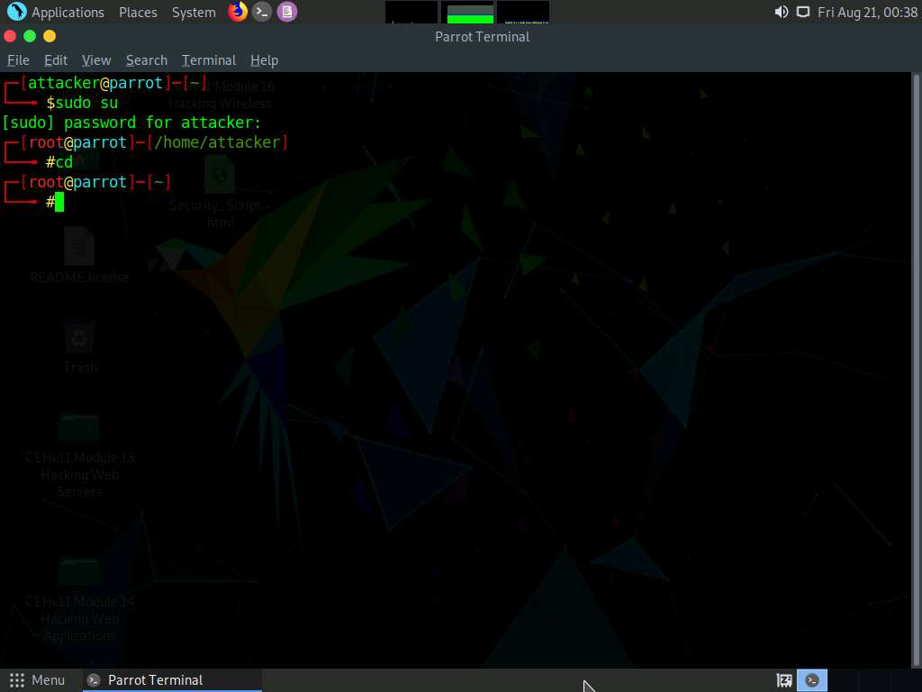

1. In the **Parrot Terminal** window, type **nmap -sU -p 161 [Target IP address]** (in this example, the target IP address is **10.10.10.16**) and press **Enter**.

**-sU** performs a UDP scan and **-p** specifies the port to be scanned.

1. The results appear, displaying that port 161 is **open/filtered** and being used by SNMP, as shown in the screenshot.

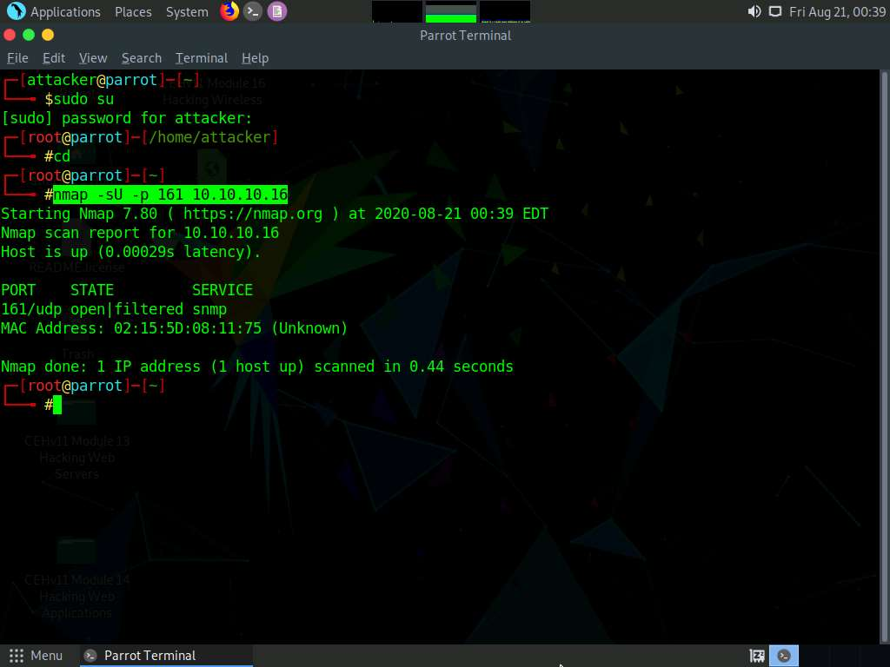

1. We have established that the SNMP service is running on the target machine. Now, we shall exploit it to obtain information about the target system.
2. In the **Parrot Terminal** window, type **snmp-check [Target IP Address]** (in this example, the target IP address is **10.10.10.16**) and press **Enter**.
3. The result appears as shown in the screenshot. It reveals that the extracted SNMP port 161 is being used by the default “public” community string.

If the target machine does not have a valid account, no output will be displayed.

1. The snmp-check command enumerates the target machine, listing sensitive information such as **System information** and **User accounts**.

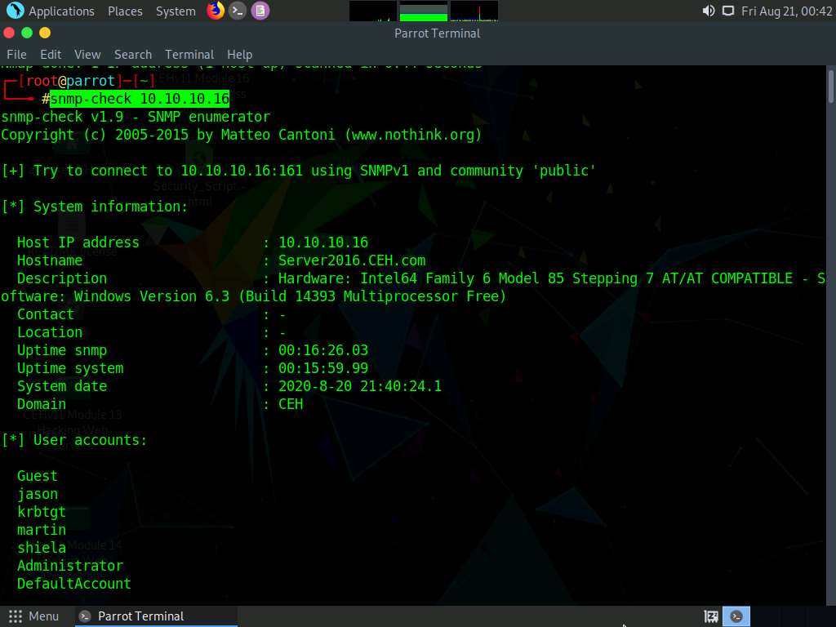

1. Scroll down to view detailed information regarding the target network under the following sections: **Network information**, **Network interfaces**, **Network IP** and **Routing information**, and **TCP connections** and **listening ports**.

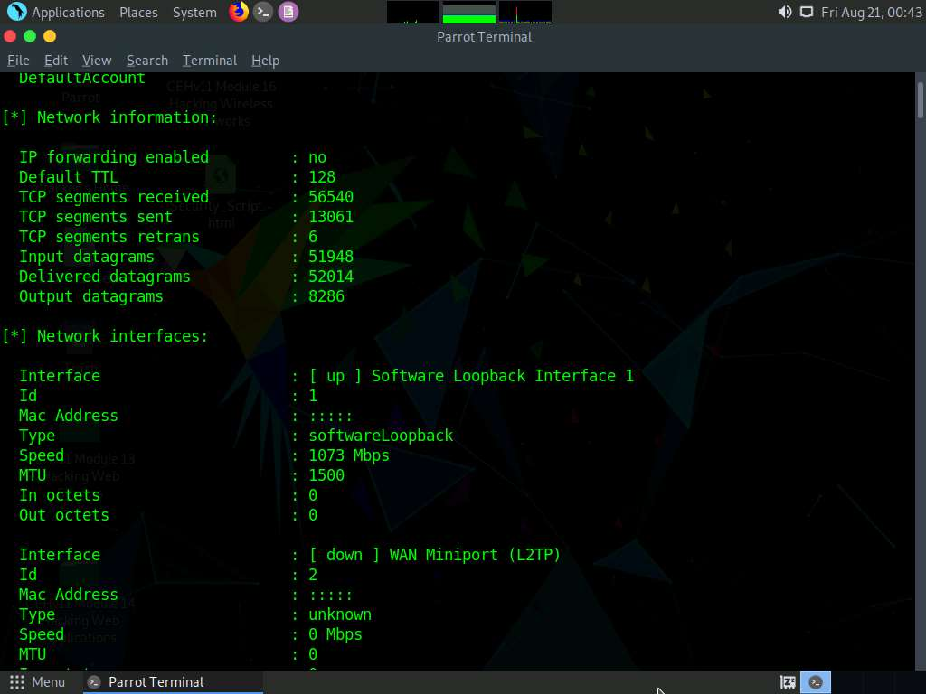

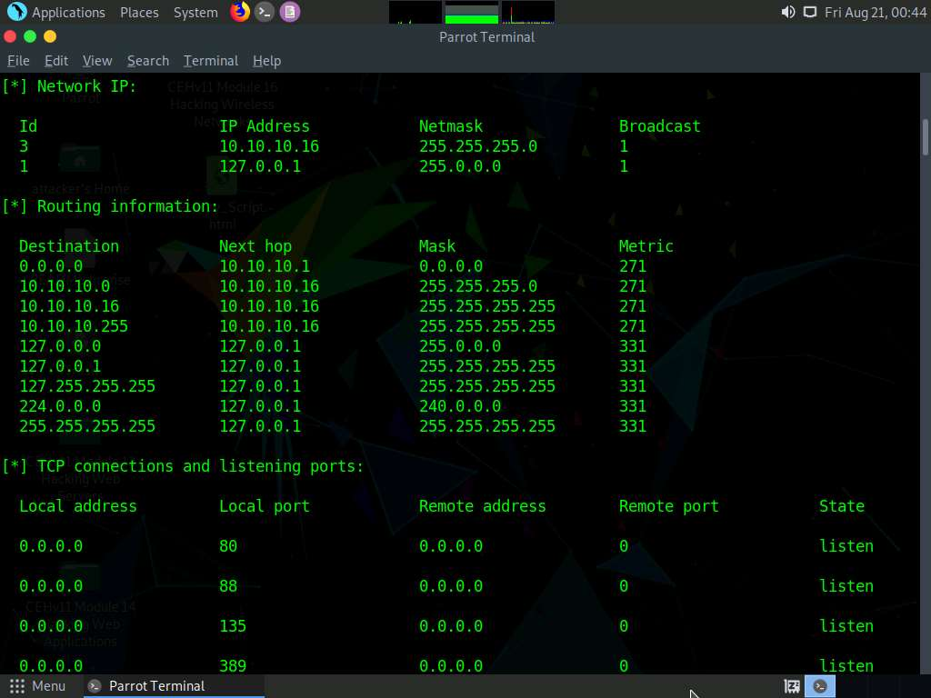

1. Similarly, scrolling down reveals further sensitive information on **Processes**, **Storage information**, **File system information**, **Device information**, **Share**, etc.

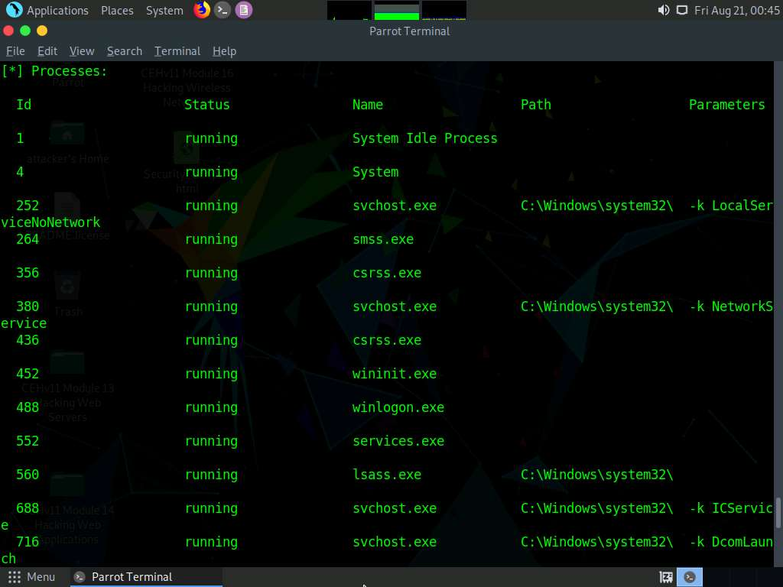

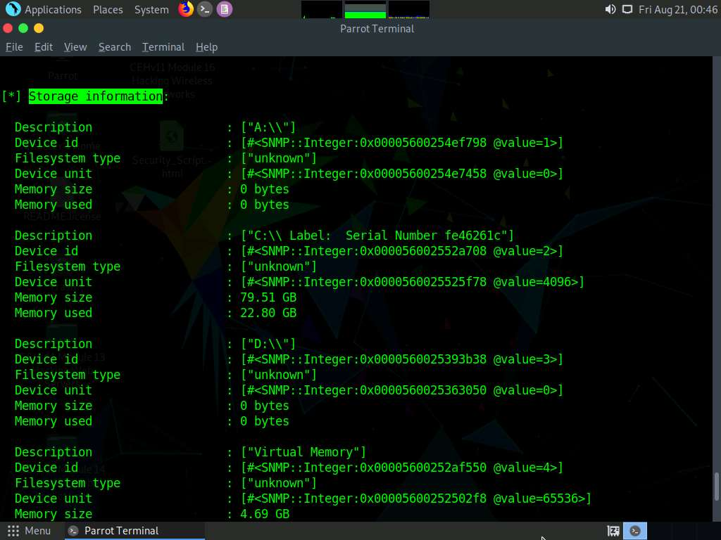

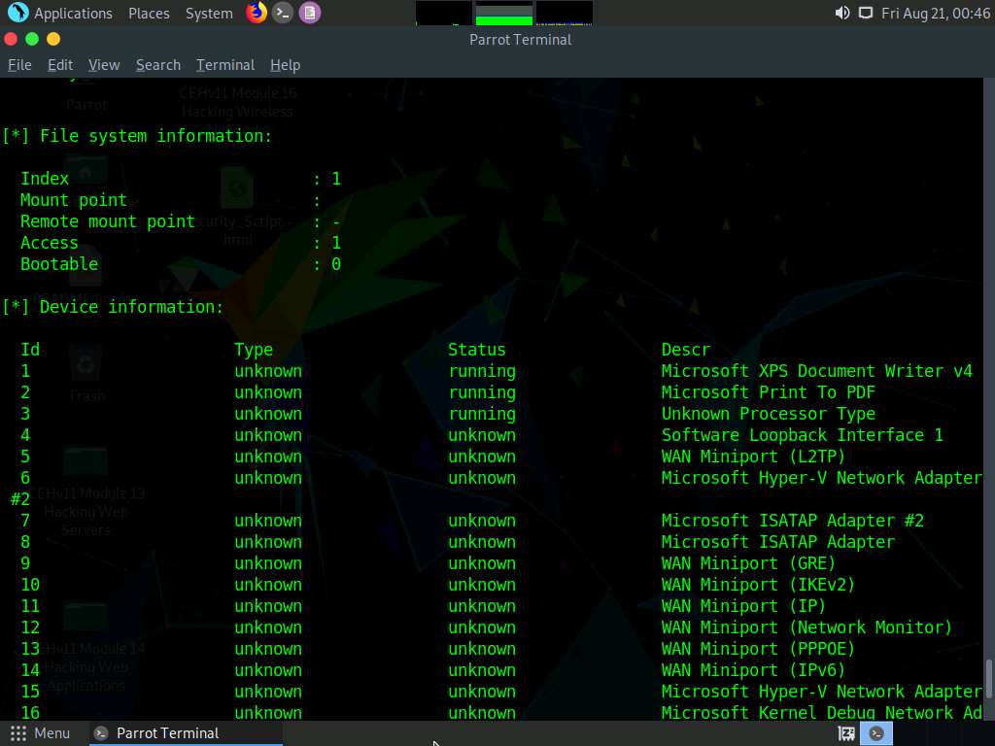

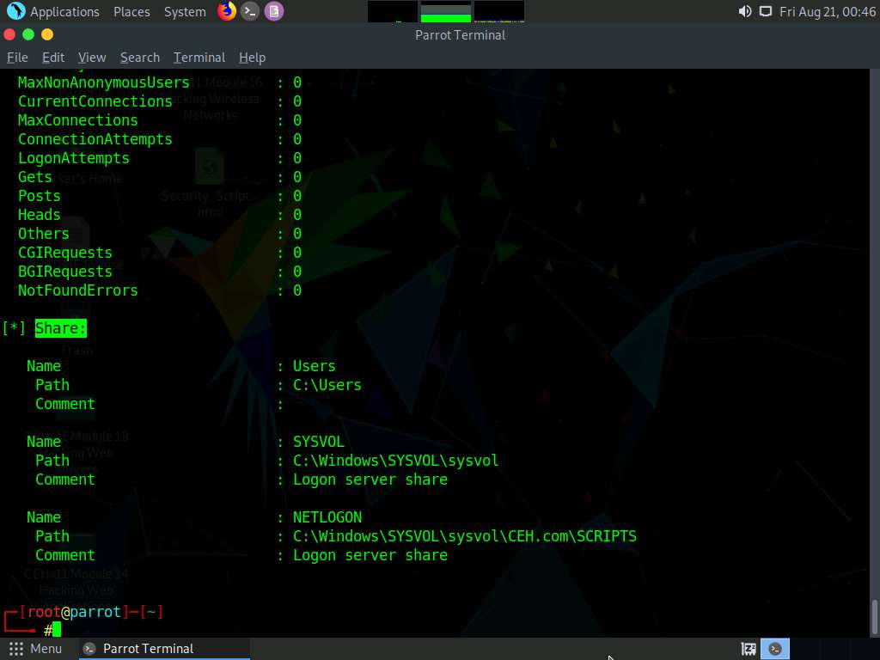

1. This concludes the demonstration of performing SNMP enumeration using the snmp-check.
2. Close all open windows and document all the acquired information.

Task 2: Perform SNMP Enumeration using SoftPerfect Network Scanner

SoftPerfect Network Scanner can ping computers, scan ports, discover shared folders, and retrieve practically any information about network devices via WMI (Windows Management Instrumentation), SNMP, HTTP, SSH, and PowerShell.

The program also scans for remote services, registries, files, and performance counters. It can check for a user-defined port and report if one is open, and is able to resolve hostnames as well as auto-detect your local and external IP range. SoftPerfect Network Scanner offers flexible filtering and display options, and can export the NetScan results to a variety of formats, from XML to JSON. In addition, it supports remote shutdown and Wake-On-LAN.

Here, we will use the SoftPerfect Network Scanner to perform SNMP enumeration on a target system.

1. Click [Windows Server 2019](https://labclient.labondemand.com/Instructions/fbc14e54-d7e0-48c8-a161-917c8a669df5?rc=10) to switch to the **Windows Server 2019** machine.
2. Navigate to **Z:\CEHv11 Module 04 Enumeration\SNMP Enumeration Tools\SoftPerfect Network Scanner** and double-click **netscan_setup.exe**.

If a **User Account Control** pop-up appears, click **Yes**.

1. When the **Setup - SoftPerfect Network Scanner** window appears, click **Next** and follow the installation steps to install SoftPerfect Network Scanner, using all default settings.
2. On completion of the installation, click **Finish**.

Ensure that the **Launch SoftPerfect Network Scanner option** is selected.

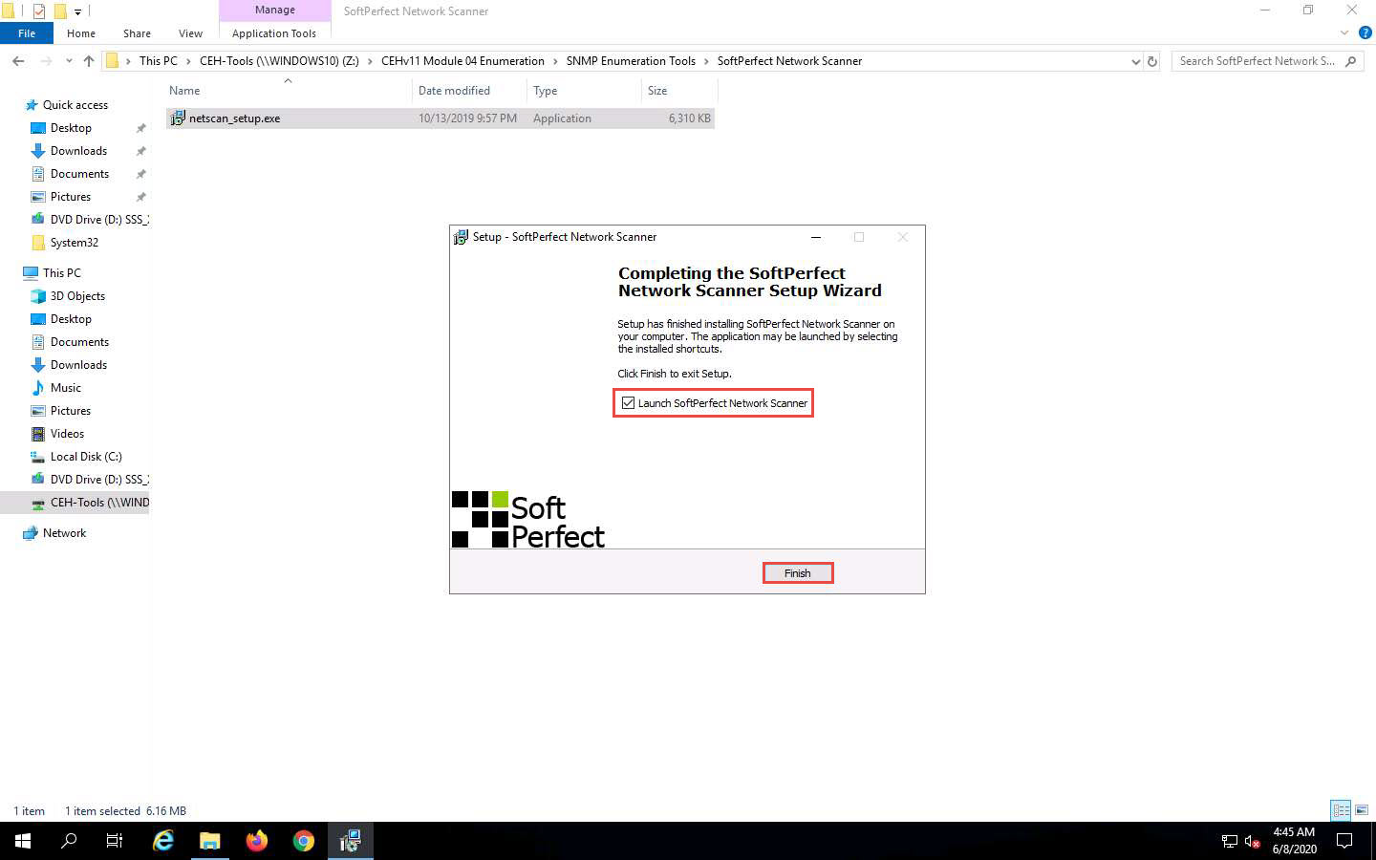

1. When the **Welcome to the Network Scanner** wizard appears, click **Continue**.

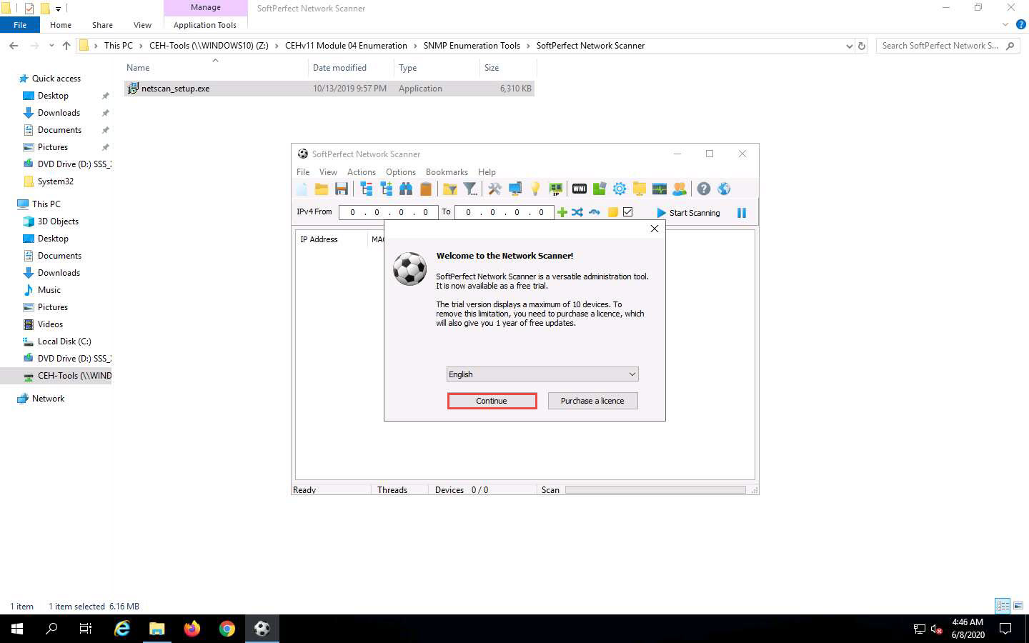

1. The **SoftPerfect Network Scanner** GUI window will appear, as shown in the screenshot.

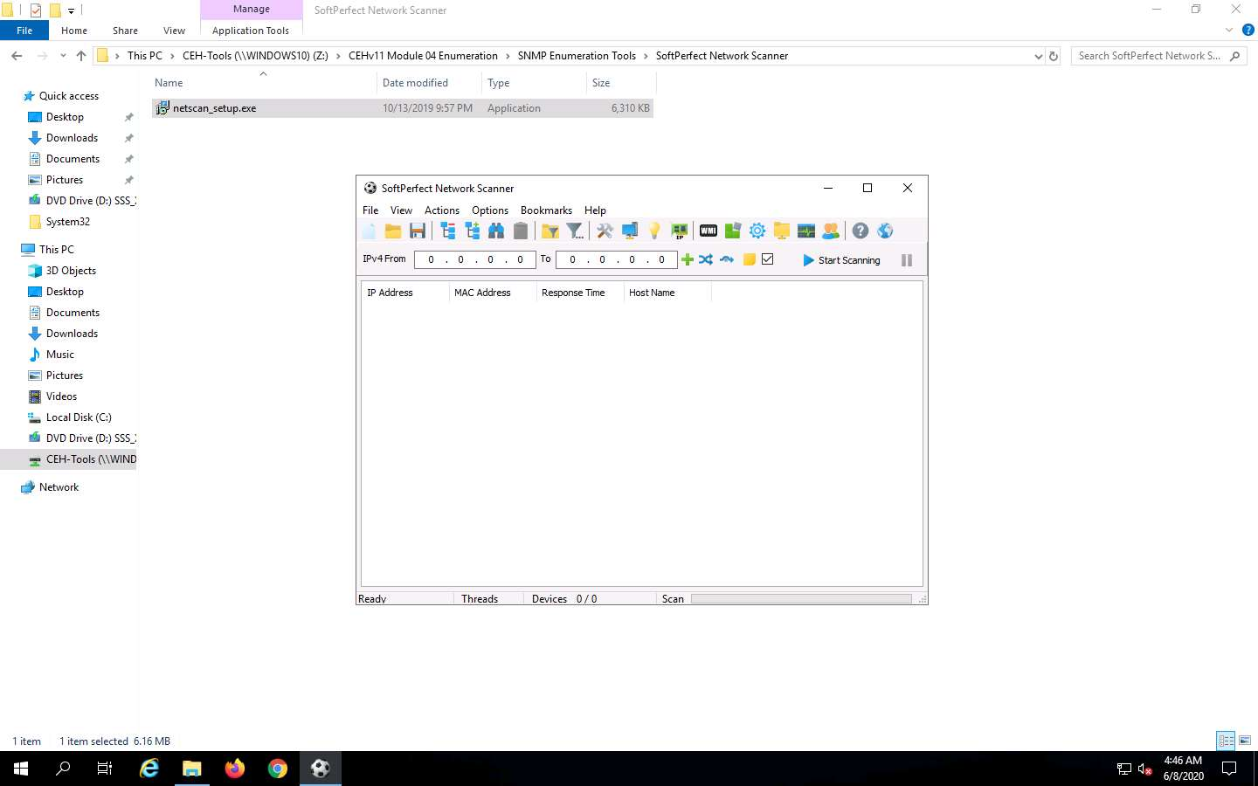

1. In the **Options** menu, click **Remote SNMP…**. The **SNMP** pop-up window will appear.
2. Click the **Mark All/None** button to select all the items available for SNMP scanning and close the window.

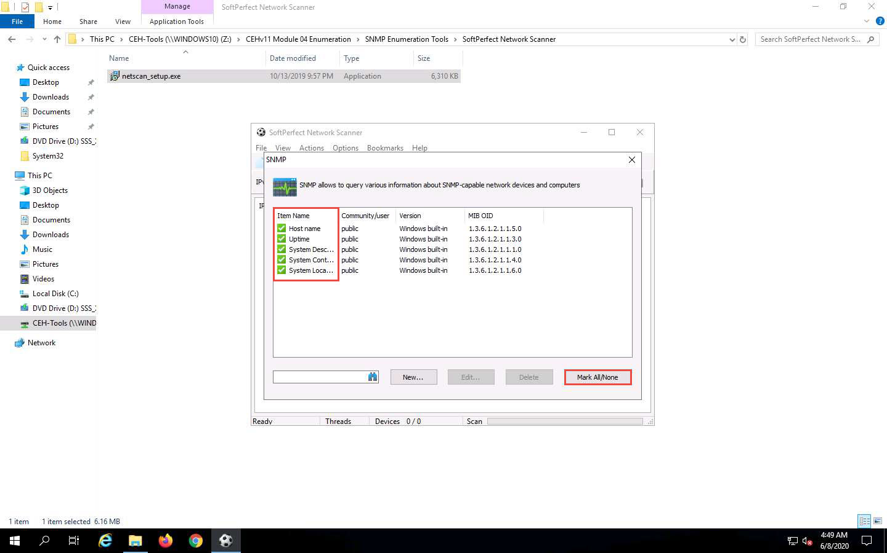

1. To scan your network, enter an IP range in the **IPv4 From** and **To** fields (in this example, the target IP address range is **10.10.10.5-10.10.10.20**), and click the **Start Scanning** button.

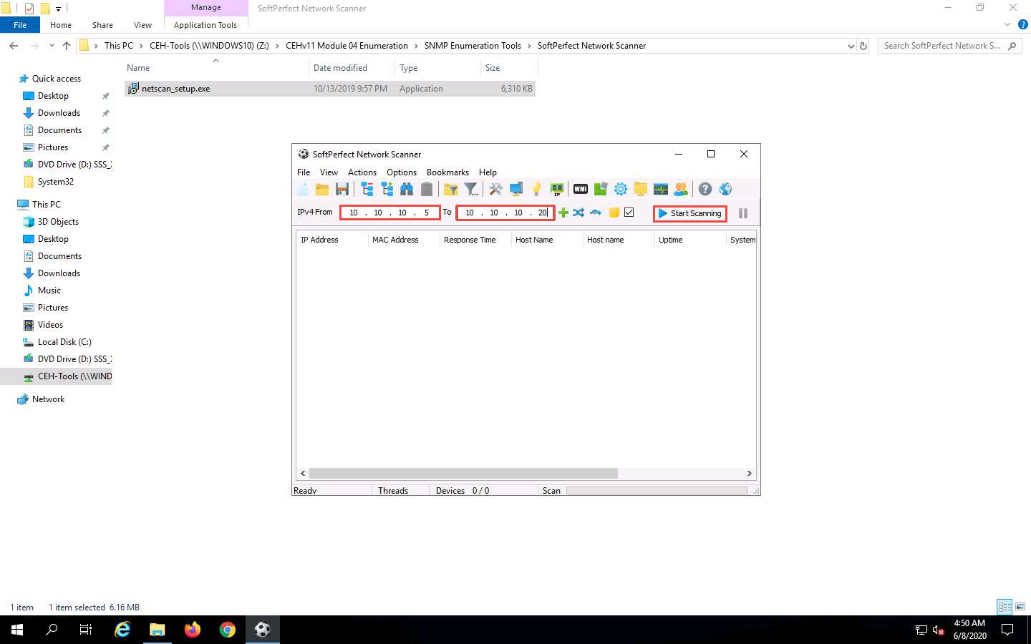

1. The **status bar** at the lower-right corner of the GUI displays the status of the scan.
2. The scan results appear, displaying the active hosts in the target IP address range, as shown in the screenshot.

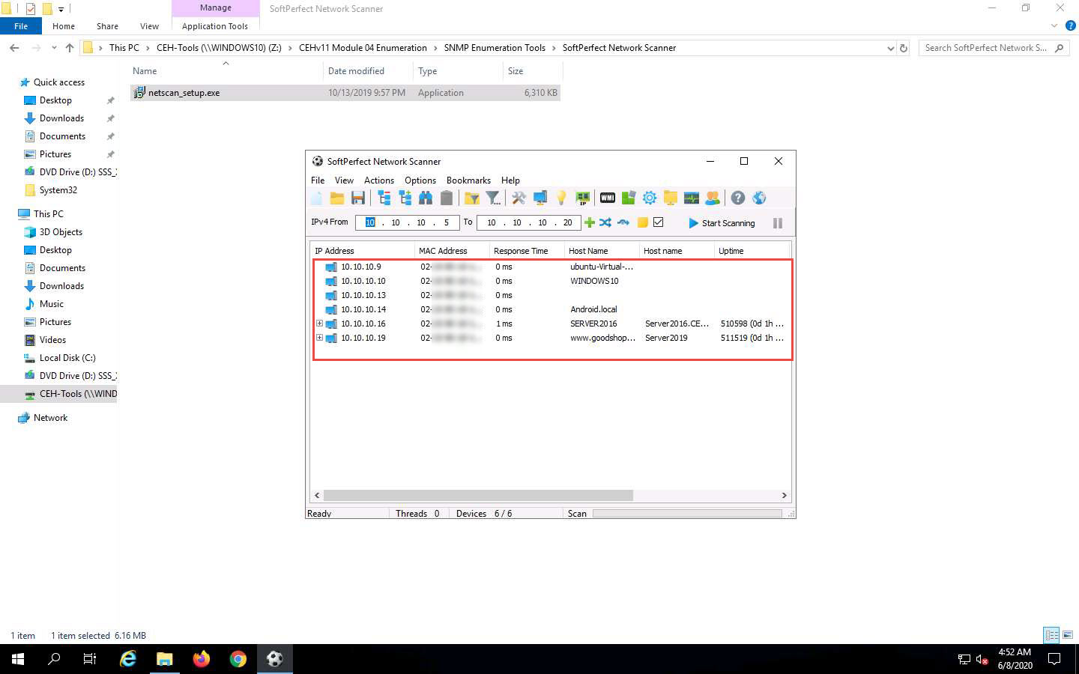

1. To view the properties of an individual IP address, right-click a particular IP address (in this example, **10.10.10.16**) and select **Properties**, as shown in the screenshot.

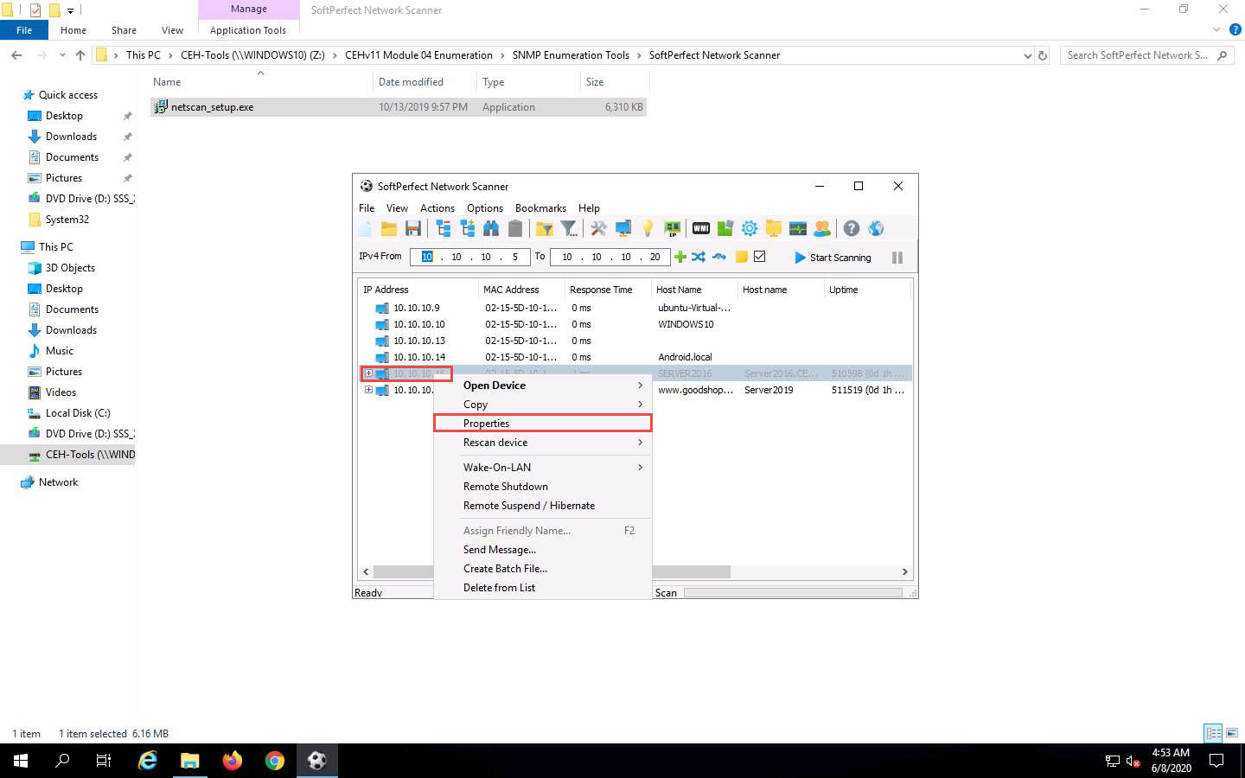

1. The **Properties** window appears, displaying the **Shared Resources** and **Basic Info** of the machine corresponding to the selected IP address.

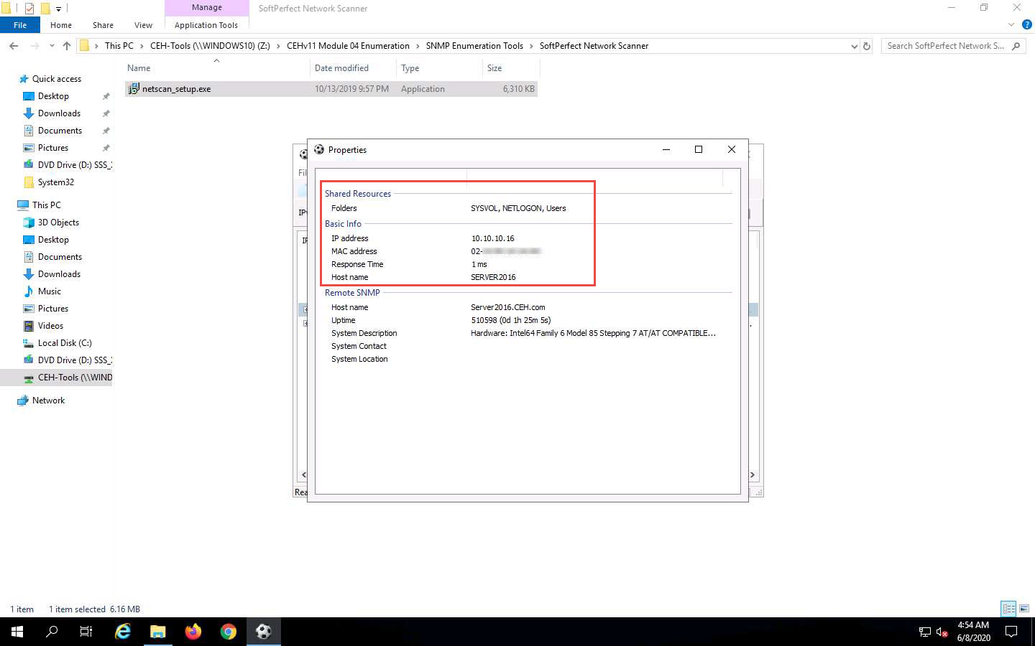

1. Close the **Properties** window.
2. To view the shared folders, note the scanned hosts that have a + node before them. Expand the node to view all the shared folders.

In this example, we are targeting the Windows Server 2016 machine (10.10.10.16).

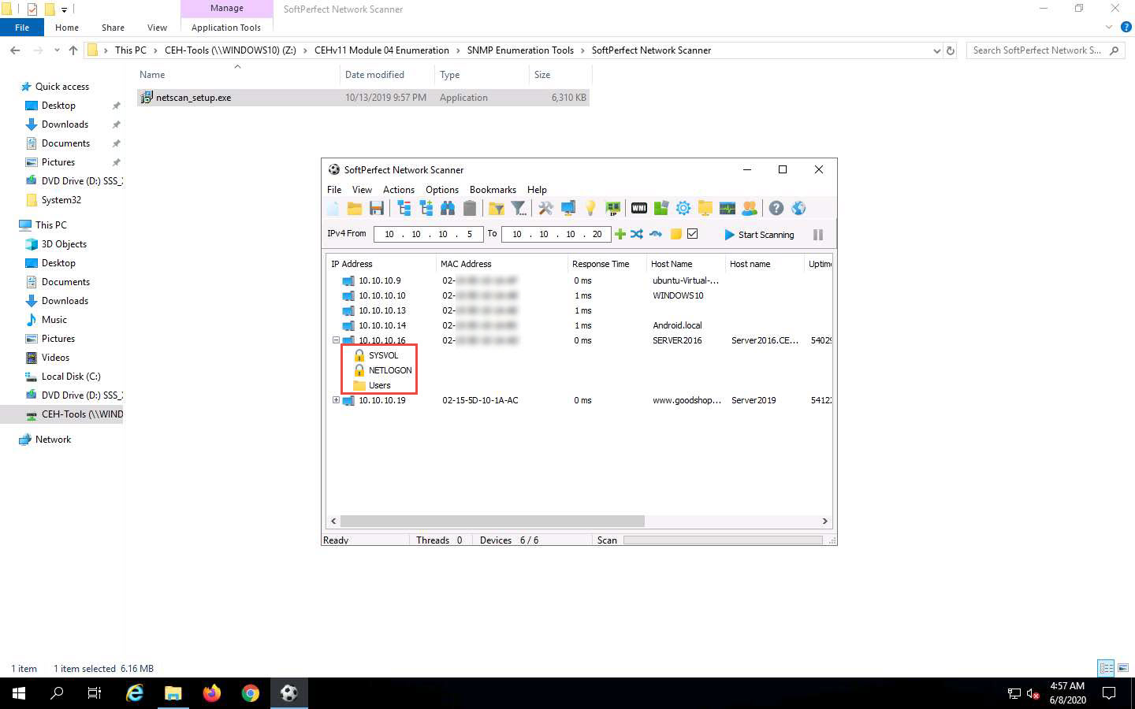

1. Right-click the selected host, and click **Open Device**. A drop-down list appears, containing options that allow you to connect to the remote machine over HTTP, HTTPS, FTP, and Telnet.

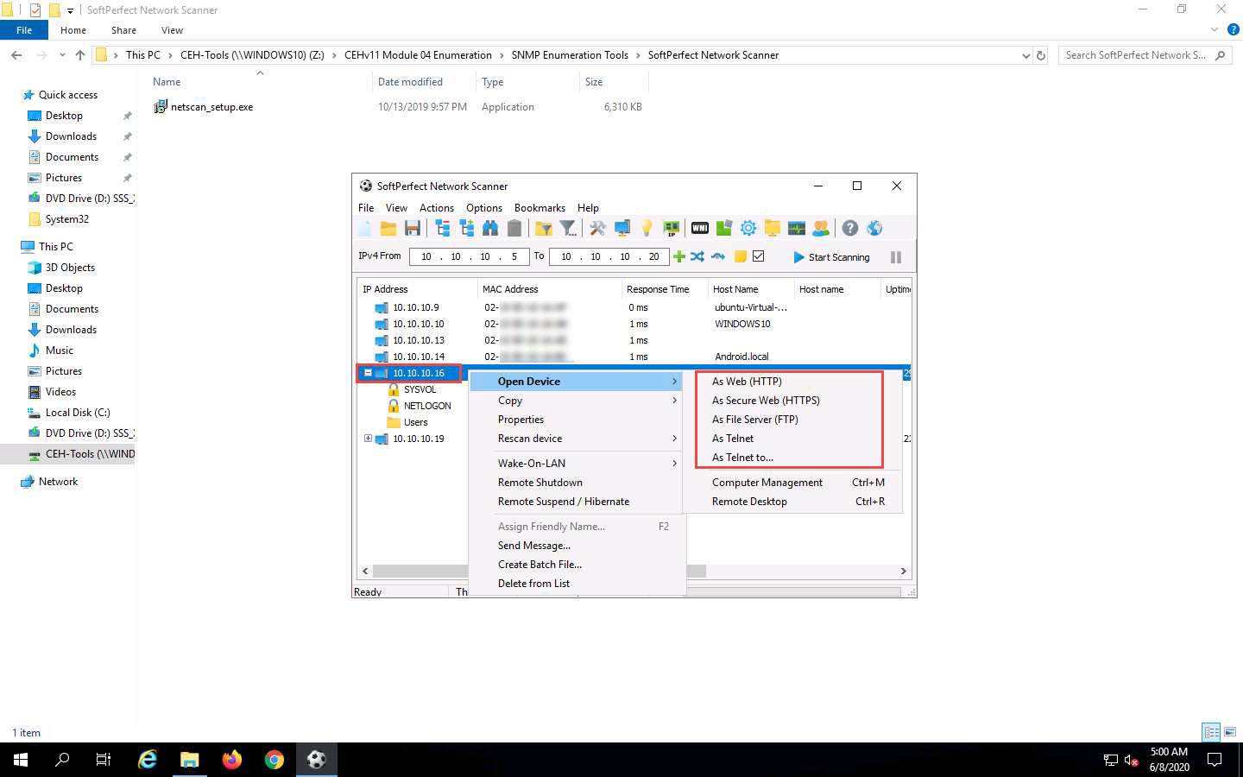

If the selected host is not secure enough, you may use these options to connect to the remote machines. You may also be able to perform activities such as sending a message and shutting down a computer remotely. These features are applicable only if the selected machine has a poor security configuration.

1. This concludes the demonstration of performing SNMP enumeration using the SoftPerfect Network Scanner.
2. You can also use other SNMP enumeration tools such as **Network Performance Monitor** (https://www.solarwinds.com), **OpUtils** (https://www.manageengine.com), **PRTG Network Monitor** (https://www.paessler.com), **Engineer’s Toolset** (https://www.solarwinds.com), and **WhatsUp® Gold** (https://www.ipswitch.com) to perform SNMP enumeration on the target network.
3. Close all open windows and document all the acquired information.